**Understanding the scaffolding mechanisms of ion channels by Magi proteins**

**Jahnavi Krishnan**

**July 25th, 2019**

**A thesis submitted to the faculty of Graduate School of the State University of New York at Buffalo in partial fulfillment of the requirements for the degree of Master of Science, Department of Pharmacology and Toxicology**

**Thesis Advisor: Arin Bhattacharjee, PhD**

**Thesis Committee: Satpal Singh, PhD; Malcolm Slaughter, PhD**

# DEDICATION

This one is for Mum, Dad and Rahul.

Thank you for being the sunshine in the snow.

I love you guys more than you’ll ever know.

# ACKNOWLEDGEMENTS

I am grateful to my Thesis advisor Dr. Arindam Bhattacharjee for believing in me when I couldn’t believe in myself and being so supportive throughout the two years. He has been more than an advisor and I would forever consider him to be a mentor in helping me shape my career in biomedical research. I extend my gratitude to my committee members, Dr. Satpal Singh for his valuable suggestions and support, Dr. Malcolm Slaughter for helping with Electrophysiological recordings and his precious inputs throughout the working of this project. They’ve been great sources of ideas for the projects, challenging my thoughts with questions and discussions.

This journey would be incomplete without my colleague and friend, Rasheen Powell who was an amazing source of positivity and ideas. I would also like to thank Dr. Kerri Pryce and Garrett Sheehan for their help and presence. Thank you all for creating a great lab environment and it was a great pleasure working with you all. I would also like to thank Ms. Divyangi Kantak and Ms. Roopa Ravichandar from the Sim Lab for their unconditional love and support. They made difficult times easier and good times last longer.

The journey would be impossible without Dr. Gary Iacobucci from the Popescu lab for sharing HEK-293 cells and GluA1 and GluA2 plasmids. He has been a constant source of discussion about gene maps, mutations and antibodies amongst other things.

Lastly, I would like to thank the entire dept. of Pharmacology and Toxicology for maintaining and providing a conducive environment for science and research.

Special thanks to Mr. S. Kulkarni, Ms. J. Dudwadkar, Ms. B. Sheth, Mr. P. Sanghvi and Mr. N. Alexander for being my Buffalo family. They’ve converted my tears into laughter, every single time.

Most importantly, I’m thankful for my strongest cheerleaders from across the oceans, my best friends, my little girl gang, Ms. M. Jawalikar, Ms. A. Iyer and Ms. S. Anupindi. Thank you for being there through it all.

Lastly, none of this would’ve been possible without my mum, dad and brother. They have been constant sources of emotional, physical and financial support. Throughout the two years, my parents have tried to cheer me up after every failed experiment, motivated me to keep going after the successful ones and relentlessly listened to my whining with love and patience. There is no easy way to tell what and how much this means to me. For this and so much more, I will be forever grateful to you all. I love you all more than I can say.

**TABLE OF CONTENTS**

DEDICATION III

ACKNOWLEDGEMENTS IV

ABSTRACT VII

CHAPTER I: INTRODUCTION 1

I. Sodium- Activated Potassium channels: 1

i. Slack KNa Channels: 2

ii. Slick KNa Channels: 5

II. AMPA Receptor: 7

i. GluA1: 10

III. Ubiquitin ligases (ULs)- 12

IV. MAGUKs: 15

A. Membrane-associated guanylate kinase, WW and PDZ domain-containing protein: 16

Magi-1: 16

Magi-2: 17

Magi-3: 17

CHAPTER II: HYPOTHESIS 19

CHAPTER III: MATERIALS AND METHODS 20

i. Cell culture: 20

ii. Plasmid Isolation: 21

iii. Primers: 22

iv. Site-directed Mutagenesis: 22

v. Western Blotting: 23

vi. Data analysis: 24

CHAPTER IV: RESULTS AND DISCUSSION 25

PART- I: Slick Channel and Magi-1 25

PART II: GluA1 subunit of AMPAR and Magi proteins 27

CHAPTER V: CONCLUSION 33

CHAPTER VI: BIBLIOGRAPHY 34

# ABSTRACT

Ion channels play important neuro-modulatory functions in neurons of the PNS and CNS. In this study we are focusing on two important ion channels of the nervous system. The first being Slick (KCNT2), a sodium-activated potassium channel notably expressed in the DRG is responsible for reducing pain and nociception due to its outward potassium current. The second being GluA1, a subunit of the AMPA receptor, widely expressed in the brain and is responsible for learning and memory formation. Through this study, we are exploring a sub-class of scaffolding proteins of the MAGUK family called Magi proteins and their interactions with these channels.

We identified the site of binding in the Slick channel N-terminus, a PPxY motif which interacts with the WW domain in Magi-1 leading to an overall increase in total protein expression of the Slick channel in CHO cells by protecting it from Ubiquitination by ubiquitin ligases (ULs) in the cytosol.

Similarly, we observed an increase in total protein expression of GluA1 in HEK-293 cells when co-transfected with Magi-2 (SSCAM), another member of the Magi family and Nedd4L, a ubiquitin ligase shown to internalize and degrade GluA1 by recognizing a Lysine (K) at the 863rd position in the C-terminus. Based on these studies, we identified a novel motif in the GluA1 C-terminus that is recognized by WW domains present in both Magi proteins and ULs. These studies help understand cytosolic protein-protein interactions between GluA1, Nedd4L and Magi-2 and hence developing these sites as potential drug targets for treatment of a spectrum of learning disorders, Alzheimer’s disease, dementias and epilepsy among others.

# 

# CHAPTER I: INTRODUCTION

## Sodium- Activated Potassium channels:

These are encoded by two genes called Slack (Slo 2.2, KCNT1) and Slick (Slo 2.1, KCNT2), first observed in cardiomyocytesKameyama et al. (1984). These channels are outward rectifying potassium channels activated by cytoplasmic increase in [Na+] concentration (Bhattacharjee et al., 2003). These channels mediate cellular physiology on expression by transient transfection and are known to modulate neuronal properties such as resting potential, action potential repolarization and regulate synaptic transmission(Bhattacharjee & Kaczmarek, 2005). Gain of function mutations in the KNa channels in neurons has shown direct relations with epilepsy and various other intellectual disabilities (Gururaj, Evely, et al., 2017). The presence of these potassium channels along the pain axis have suggested roles for these channels in pain and nociception (Evely, Pryce, Bausch, et al., 2017), (Tomasello, Hurley, Wrabetz, & Bhattacharjee, 2017), (Gururaj, Evely, et al., 2017).

The KNa channels consist of an alpha-subunit that assembles in a tetrameric membrane protein complex to form physiological functioning channels. The alpha subunit comprises the cytosolic N-terminus and C-terminus along with a hydrophobic core region made up of six alpha helical transmembrane domains (designated as S1 to S6). The pore lining domain (also called P-region) is formed by a membrane hydrophobic loop along with the S5 and S6 transmembrane segments (Chen et al., 2009). These KNa channels, however possess no charged residues in the S4 domain, responsible for voltage sensitivity of these channels. Despite having large transmembrane domains, the core region of the Slack KNa makes up 1/7th of the total protein (Kaczmarek, 2013). The long C-terminus, responsible for neuromodulatory functions makes up for about 70% of the channel. The C-terminus consists of a number of domains and motifs suggesting their role in tightly regulating channel function in their expressional sites.

Both Slack and. Slick channels showed significant expression in different regions of the rodent brain including brainstem, deep cerebellar nuclei, substantia nigra, vestibular and oculomotor nuclei, olfactory bulb, auditory system, red nucleus, amygdala and thalamus (Bhattacharjee, Gan, & Kaczmarek, 2002). KNa channels have expressed in the Peripheral Nervous System. Within the DRG, Slack is present in the peptidergic and non-peptidergic neurons (Nuwer, Picchione, & Bhattacharjee, 2009) whereas Slick channels are preferentially expressed in CGRP-positive peptidergic DRG neurons (Tomasello et al., 2017). Apart from the CNS and PNS, Slack and Slick are also expressed in the heart and kidneys and exhibit diverse functions (Bhattacharjee, von Hehn, Mei, & Kaczmarek, 2005). Studies have suggested that Slack and Slick channels influence normal development of neurons, synaptic plasticity and neuronal function. Hence, the mechanisms underlying Slack and Slick membrane localization and trafficking could help provide great insights on factors influencing channel function.

1. Slack KNa Channels: Abbreviated as ‘Sequence like a Ca2+-activated K+ channel’, have a large unitary conductance of approximately 180pS(Bhattacharjee et al., 2002). They display slower inactivation kinetics (compared to the Slick channel) in response to cytosolic increases in Na+ concentration and are weakly dependent on intracellular Chloride ion concentration(Kaczmarek et al., 2005); (Tamsett, Picchione, & Bhattacharjee, 2009). These channels regulate neuronal plasticity in two ways; (1) by affecting the resting membrane potential and (2) by adapting to high frequency AP firing by affecting the slow Afterhyperpolarisation (sAHP) in neurons, these are critical for synaptic transmission and hormone release in neuroendocrine cells (Bhattacharjee & Kaczmarek, 2005). Neuronal stimulation drives sodium into the cell, activating the KNa channels. The high frequency AP firing in neurons increase the intracellular Na+ concentration, critical for activating Slack channels. Na+ influx into the neuron is through persistent voltage-gated sodium channels and the ionotropic ligand gated glutamate channels AMPA and NMDA receptors and hence believed that KNa channels are coupled to these Na+ sources.

Transient activation of KNa channels is produced by Na+ influx through voltage-gated Na+ channels during AP firing (Bader, Bernheim, & Bertrand, 1985); (Dryer, Fujii, & Martin, 1989). Functional coupling of Slack channels with voltage-gated sodium channels was shown by electrophysiological evidence (Hage & Salkoff, 2012).

The extensive C-terminal has several protein binding motifs and hence is a part of various intracellular signaling pathways. There are two predicted regulators of conductance of K+ (RCK) domains, an Na+ binding region, an NAD+ binding site which allosterically regulates channel opening (Tamsett et al., 2009), Protein Kinase A and Protein Kinase C (PKA/PKC) phosphorylation sites, an Adaptor protein (AP-2) binding site for channel internalization (Gururaj, Evely, et al., 2017) and a distal C-terminal Post Synaptic/Disc Large/ZO-1 (PDZ) binding motif.

PKA activation was responsible for Slack channel internalization is dependent upon adaptor protein 2/clathrin-mediated endocytosis (AP2-CME) (Nuwer et al., 2009); (Gururaj, Evely, et al., 2017). A decrease in the expression of the Slack channel at the membrane has shown links to loss of firing accommodation and neuronal hyperexcitability. Hence, there is an overall increased interest in these cellular mechanisms underlying Slack channel function, trafficking and membrane localization. Implications of Slack in disease pathologies direct towards neuropathic and inflammatory pain, epilepsy and intellectual disabilities (Kim & Kaczmarek, 2014); (Evely, Pryce, & Bhattacharjee, 2017). Studies have also shown that trafficking of the Slack channel to and from plasma membrane in neurons effectively regulates excitability and hence lead to discovery of novel targets to treat neuropathic pain (Pryce et al., 2019)

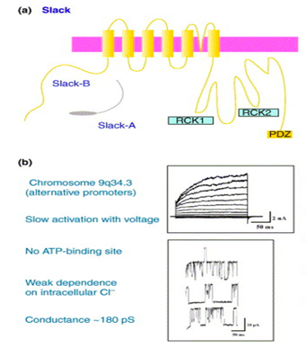(Bhattacharjee and Kaczmarek, 2005)

1. Slick KNa Channels: Abbreviated as ‘Sequence like an intermediate conductance potassium channel’ (Kcnt2, Slo 2.1, KNa 1.2), is a member of the KNa channel family and displays approximately 74% sequence homology to Slack channels (Bhattacharjee et al., 2005). These channels have a very large unitary conductance of approximately 140pS and show rapid activation kinetics as a response to depolarization. They have a basal level of activity despite Na+ absence. Slick channels contain a consensus ATP binding site downstream of RCK domains that regulates Slick current amplitude and are strongly influenced by intracellular Chloride ion concentration. It was shown that an increased concentration of the Chloride ions was greater for Slick channel activation than the Slack channel (Bhattacharjee & Kaczmarek, 2005).

Slick channels have a structurally different N-terminal from the Slack channel. It contains a putative PY (PPxY, where x is any amino acid) motif in its N-terminus. The PY motif is a consensus binding site for WW (Tryptophan-Tryptophan) domain containing proteins (Pryce et al., 2019). Slick also contains a conserved PDZ-binding motif in the C-terminus that could potentially localize the channel to the neuronal membrane through association with scaffolding proteins containing PDZ domains.

Studies have shown that Slick channel regulates neuronal hyperexcitability suggesting a role in inflammatory and neuropathic pain in rodent models. Electrophysiological recordings of DRG neurons from Slick knockout mice showed that these channels contribute to outward Potassium current and AP firing (Tomasello et al., 2017). Gain of function mutations in the Slick channel have shown association with epileptic encephalopathy as a result of significant increase in AP firing (Gururaj, Palmer, et al., 2017).

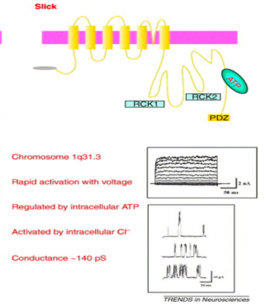(Bhattacharjee and Kaczmarek, 2005)

## AMPA Receptor:

The AMPA (α-amino 3-hydroxy 5-methyl 4-isoxazole propionic acid) receptors are glutamate-gated ion channels that mediate the majority of fast excitatory transmission in the Central Nervous System regulating learning, memory and cognition. Binding of Glutamate to the receptor, the pore of the receptor opens up allowing influx of Na+ ions, depolarizing the post synapse (Chater & Goda, 2014). These ion channels are subject to trafficking, recycling and degradation thus directly having implications in memory formation and storage through an increase in repetitive firing through the channel, increasing the strength of the synapse. In the principal neurons of forebrain are monovalent ion channels and display strict impermeability to calcium ions (Bredt & Nicoll, 2003). They are composed of hetero-oligomeric or homo-oligomeric combinations of four pore-forming subunits (GluA1-4). AMPARs are present at the synapse usually consist of tetramer combinations of GluA1 and GluA2 (Henley & Wilkinson, 2013); (Martenson & Tomita, 2015). They are responsible for synaptic transmission and form the primary driving force for postsynaptic depolarization, playing a major role in synaptic communication (Lu & Roche, 2012).

The AMPARs are majorly distributed throughout the CNS. Their high expression in the hippocampus has helped elucidate the role of AMPARs in memory formation, cognition, learning and application. Within the neurons, AMPARs are known to be present both post-synaptically and pre-synaptically. They are also expressed in glial cells and appear to be involved in glutamate-induced cell death. Spatial learning is mediated by an increase in the synaptic surface expression of AMPARs and in regulated by insertion of GluA1 (Sanderson et al., 2009).

The AMPA receptor subunits GluA1, GluA2, GluA3 and GluA4 (also referred as GluRs) exhibit similar structure, topology and sequence homology. They have an N-terminal domain followed by S1 and S2 forming the Glutamate binding site. Two hydrophobic segments are trans-membranal and one dips into the membrane from the cytoplasm forming the channel pore. S2 is followed by Flip/flop splice variant region and one transmembrane domain and the C-terminus containing the PDZ-binding domain. The channel’s pharmacological and kinetic properties are regulated by the splice variants, “flip” and “flop”. The splice variants show differential responses to Glutamate and kainate (Bredt & Nicoll, 2003). The representative scheme is shown below.

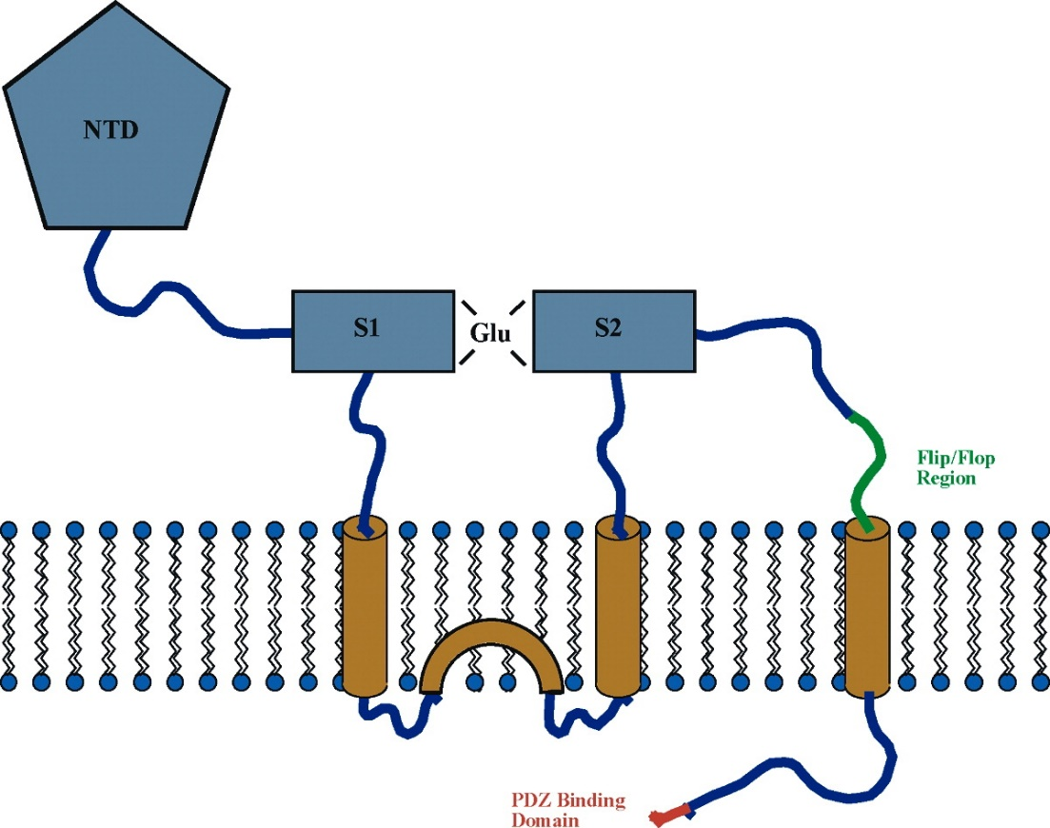

Scheme 1: Schematic Diagram of an AMPA receptor subunit. Adapted from Bredt and Nicoll, 2003

Studies have shown that trafficking of the channels and functional properties of the AMPA receptor, important for developing synaptic strength are based on subunit composition along with the protein-protein interactions and post-translational modifications. This dynamic process of trafficking and synaptic localization is important for maintaining and developing synaptic plasticity and is believed to be underlying molecular mechanisms behind learning and memory (Bredt & Nicoll, 2003). There is a dynamic adjustment and regulation of expression of these AMPARs by a delicate balance between biosynthesis, dendritic transport, exocytosis, endocytosis, recycling and degradation of the receptors. Recent studies have shown implications of protein ubiquitination a regulator of intracellular receptor trafficking playing a role in Alzheimer’s disease, epilepsy and chronic stress (Widagdo, Guntupalli, Jang, & Anggono, 2017).

Synaptic localization of the Glutamate receptors is one of the primary mechanisms for initiation and development of Long-term potentiation (LTP) and Long-term Depression (LTD), major players in memory formation and consolidation. LTP refers to the persistent strengthening of chemical transmission following patterns of high-frequency stimulation of a synapse, making it an input-specific process and greatly influence the large information encoding capacity of the brain (Bellinger et al., 2006). Primarily triggered by NMDA receptor activation, it is also shown to be modulated by synaptic plasticity by AMPA receptors at excitatory synapses in the mammalian brain. There have been studies showing that increased LTP co-relates to an increase in the number of AMPARs in the postsynaptic membrane (Park, 2018). Both LTP and LTD require the addition or removal of synaptic AMPARs hence studying the underlying mechanisms that regulate their trafficking are critical for synaptic plasticity and human cognitive behaviors. They are regulated through a continual endocytosis, sorting and recycling to the cell surface or lysosomal degradation (Chiu et al., 2017). AMPAR trafficking from the endoplasmic reticulum is also regulated by various accessory proteins such as TARPs and cornichons. Studies have also shown that GRIP1 and dynein may also be involved. Moreover. AMPAR subunits are regulated differentially by neuronal activity through enzyme mediated phosphorylation and dephosphorylation cycles driving their insertion and removal from the synapse (Chater & Goda, 2014). AMPAR trafficking is also shown to be regulated through the C-terminal cytoplasmic tails due to their interactions with underlying scaffolding proteins or phosphorylation of amino acids (Derkach, Oh, Guire, & Soderling, 2007). Our studies focus on the first subunit of the AMPARs, GluA1 which is explained in detail below.

### GluA1:

It is broadly expressed in most brain regions, though absent from thalamus and mesencephalon and displays sequence homology with the other subunits GluA2, GluA3 and GluA4, representing the family of AMPA receptors in the CNS (Hollmann & Heinemann, 1994). It is responsible for the Ca2+-permeability of the channel and hence shows an important neuro-modulatory function in the development and maintenance of LTP. GluA1 has shown its significance for rapidly induced, short-lasting form of potentiation and is critical for the formation of memory traces underlying familiarity with regard to spaces (Sanderson et al., 2009). Despite having homology, GluA1 channels exhibit pharmacologically distinct functions. The topology depicts a large extracellular N-terminal region followed by a membrane-spanning domain. The second hydrophobic segment dips into the membrane from the cytosolic side, forming the channel pore. It is followed by another transmembrane domain, an extracellular loop (consisting of the Flip-Flop splice variant region), the third transmembrane region and the cytoplasmic tail.

GluA1 also has Serine-rich sites of phosphorylation in the cytosolic C-terminus and a mutation in these sites lead to a greater loss at the synapse suggesting a role for this subunit in bidirectional synaptic plasticity by modulating LTP and LTD.

Recent studies have implicated that GluA1 ubiquitination of GluA1 by E3 ubiquitin ligase is responsible for its internalization and proteasomal degradation. GluA1 is degraded in an activity-dependent fashion by ubiquitin ligase, Nedd4-1 (Schwarz, Hall, & Patrick, 2010). However, recent studies exploring mutations in the extensive C-terminus of GluA1 have shown impaired ubiquitination and greater seizure susceptibility of the cortical neurons (Schwarz et al., 2010); (Zhu et al., 2017). These studies form the basis of our studies where we are trying to understand the protective mechanisms by scaffolding proteins against these ubiquitin ligases.

## Ubiquitin ligases (ULs)-

Ubiquitination is a reversible post-translational modification regulating a variety of physiological processes which include protein degradation, endocytosis, sorting and trafficking of transmembrane proteins (Widagdo et al., 2017). It is also shown that this dynamic process serves as an intracellular signal for membrane protein sorting and trafficking as a medium for cell-specific functions (Schwarz et al., 2010). Ubiquitously expressed in all eukaryotes, Ubiquitin is a small 76 amino acid protein (8.6 kDa) which covalently binds to other proteins in a series of reactions catalyzed by E1, E2 and E3.

* E1 activates Ubiquitin through ATP-dependent pathway
* E2, also known as Ubiquitin-carrier enzymes and helps conjugate with several ubiquitin ligases
* E3, a ligase that links Ubiquitin to its substrate at Lysine (K) to determine substrate specificity.

Ubiquitination of membrane proteins functions as a tag and in recognized by endocytotic machinery eventually leading to receptor internalization followed by proteasomal degradation of proteins involved in neurodegenerative diseases such as Alzheimer’s disease or Parkinson’s disease (Lin et al., 2011); (Ardley, Hung, & Robinson, 2005).

The E3 ubiquitin ligases are a diverse section of proteins, particularly involved in the substrate specificity and subsequent degradation of the protein. They are characterized by this specific motif called the HECT (homologous to E6-associated protein C-terminus) domain, RING (Really interesting new gene) or a U-box (a modified ring motif) domains (Ardley & Robinson, 2005).

The Nedd4 gene encodes for the nine members of the Nedd4 family of ubiquitin ligases. These consist of a Ca2+ and phospholipid binding domain, three putative WW domains and a carboxyl-terminus region similar to the HECT domain. Studies demonstrate the need for evolutionarily conserved WW domains important for substrate recognition and the HECT domain for the ubiquitin ligase (UL) activity. Localized in the cellular cytoplasm, the expression of Nedd4 in the CNS is maximum during neurogenesis and is decreases as development increases. (Kumar et al., 1997); (Donovan & Poronnik, 2013).

Of the members of Nedd4 family, the Nedd4-2 gene is demonstrated to be associated with Epilepsy by mediating spontaneous neuronal and synaptic activity, increasing susceptibility of seizures by ubiquitinating and internalizing the GluA1 subunit of AMPA receptors in cortical neuronal cultures. Hence showing that impaired ubiquitination (because of Nedd4-2 knockdown) of GluA1 could lead to seizures. Nedd4-2 is also known to regulate ENaC in the kidney offering physiological modulation of ion channels in the kidney cells (Donovan & Poronnik, 2013).

Scheme 3 depicts Nedd4 family’s structural domains and most notable members involved in neurodegeneration.

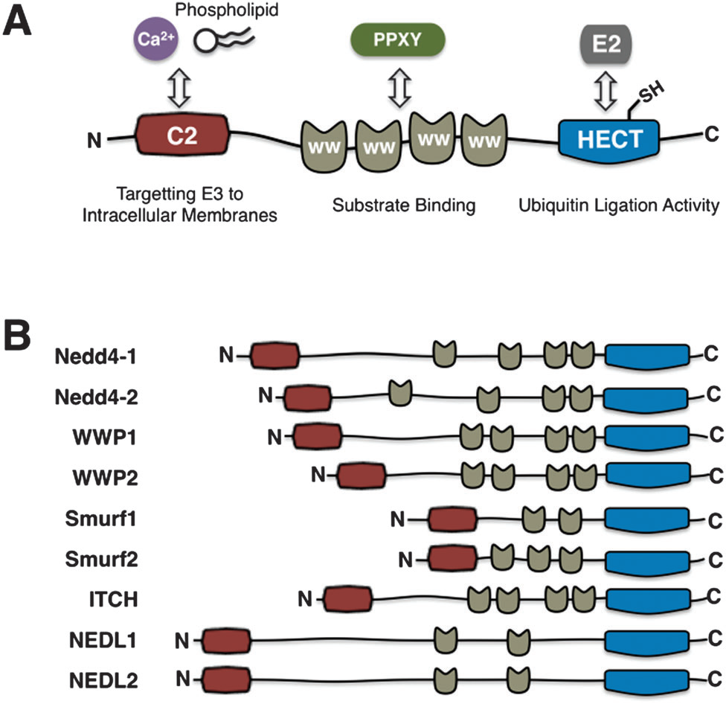

Heeseon et al., Mol BioSys 2014

Scheme 3 depicting the UL family with the different domains and their recognition sites adapted from (Chater & Goda, 2014)

## MAGUKs:

These stand for Membrane Associated Guanylate Kinase (MAGUKs) and are a super-family of scaffolding proteins containing multiple protein binding domains. They’ve been known to be responsible for spatial organization at epithelial tight junctions and neuronal synaptic junctions (pre and post-synaptic compartments) (Dunn & Ferguson, 2015). Cell processes such as cell-cell communication, formation and maintenance of cell polarity along with cellular transductions are arbitrated by these scaffolding proteins. The presence of protein-binding domains allows for MAGUK protein interactions with other cytoskeletal proteins, ion channels at specific cellular locations. They regulate cellular physiology by affecting the trafficking, membrane tethering and internalization of ion channels and receptors. These effects are determined by the protein-interacting domains present on them and this varies within members of the MAGUK super-family of scaffolds and subfamilies of these proteins. The super-family is further sub-divided based on similarity of these domains, however, all the members of the MAGUKs are known to have one or more PDZ domains, Guanylate kinase (GK) domains, Src Homology (SH3) and or WW (Tryptophan-Tryptophan**)** domains. Some subfamilies of the super family include the Maguk Palmitoylated proteins (MPPs), Zona Occludens (ZO), Caspase Recruitment Domain-containing MAGUK protein (CARMA), Discs larges (DLGs) and MAGUKs with inverted orientation (MAGI) proteins (Oliva, Escobedo, Astorga, Molina, & Sierralta, 2012).

### 

### A. Membrane-associated guanylate kinase, WW and PDZ domain-containing protein:

This sub-family of scaffolding proteins from the MAGUK super family, called the Magi proteins are uniquely characterized by six PDZ (Post Synaptic/Disc Large/Zona Occludens-1) domains, one catalytically active guanylate kinase domain and two WW domains (Dunn & Ferguson, 2015; Oliva et al., 2012). Studies have shown that WW domains have an absolute requirement for PPxY motifs for binding. These motifs have been found in Slick and voltage-gated sodium channel, Nav1.8. Recent studies have indicated that WW domains also bind to other novel motifs such as a Proline-Arginine motif (Bedford, Sarbassova, Xu, Leder, & Yaffe, 2000).

Three known isoforms; Magi-1, Magi-2 and Magi-3 are known and show similarity in structure, function and distinct cellular localization. Within the nervous system, Magi-1 is present along with presynaptic proteins such as synaptophysin whereas Magi-2 and Magi-3 localize to the postsynaptic density (Ito et al., 2012).

#### Magi-1:

The first member of the Magi family, Magi-1 is an essential scaffold at the tight junctions through its PDZ and WW domains with the distal C-terminal PDZ motif and PY motifs of ion channels, receptors and signaling molecules. Studies have shown predominant expression in non-neuronal tissue. However, recent studies have shown that Magi-1 is highly expressed in the DRG and hippocampus (Bio GPS) indicating localization with Slack, Slick and AMPARs. Recent studies have shown importance of Magi-1 in the regulation of neuronal excitability by modulating trafficking to the cellular membrane of Slack channels implicating its role in chronic pain (Pryce et al., 2019).

Previously shown to interact through its PDZ and WW domains with the distal C-terminal PDZ motif and PY motifs of ion channels, receptors and signaling molecules which include acid-sensing ion channel (ASIC3), calcium-activated potassium channel subunit Slo1 and the p75 Neurotrophic Receptor (p75-NTR) amongst others. These are key regulators of neuronal excitability and hence hint towards Magi-1 being involved in firing of APs from neurons.

#### Magi-2:

Also known as Synaptic Scaffolding Molecule (SSCAM), acts as an assembling molecule for multiprotein complexes responsible for development and perpetuation of the synapse. Magi-2 is expressed considerably in the kidneys and the brain. It is also expressed in the pancreas, heart ovaries and skeletal muscle. Abundantly present in the neuronal tissues have been shown to localize at the post-synapse preferentially, where it interacts with another glutamate receptor N-methyl-d-aspartate (NMDA) (Hirao et al., 2000). Magi-2 plays an important protective role for proteins targeted for proteasomal degradation through ubiquitination by E-3 ubiquitin ligase, Nedd4L (or Nedd4-2) (Shirata et al., 2017; Xu et al., 2001). Studies have also shown that SSCAM is an essential scaffold in maintenance of GluA2-containing pool of AMPARs (Danielson et al., 2012). Magi-2 is a critical scaffold for kidney barrier function with a putative tumor-suppressor role. Magi-2 knockout mice suffer neonatal lethality and have abnormally long dendritic spines (Balbas et al., 2014).

#### Magi-3:

The third member of the Magi family, is ubiquitously expressed in the PNS and CNS. Immunohistochemical analysis of adult mouse brain detected Magi-3 in subclasses of neurons that showed high TGF-alpha in the neurons of the cortex, dentate gyrus, ependymal cells and also in the astrocytes (Franklin et al., 2005). Magi-3 is also known to regulate numerous other cellular signal transduction pathways such as the RhoA pathway and the ERK1/2 pathway (Zhang, Wang, Sun, Hall, & Yun, 2007).

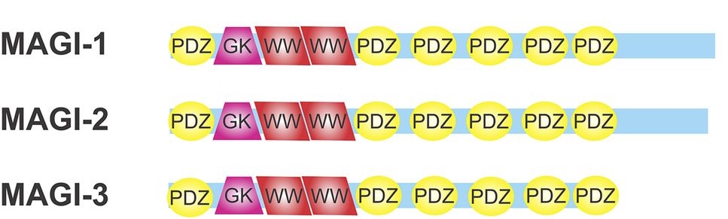

Adapted from Dunn and Ferguson, 2015

# CHAPTER II: HYPOTHESIS

1. ***Slick channel (KCNT2, Slo 2.1) binds to Magi-1 through a conserved motif at the N-terminus:***

We hypothesized that Magi-1 binds through its WW binding domain to the Slick channel’s PPxY motif thereby preventing ULs (Ubiquitin Ligases) from degrading channel and preventing it from trafficking to the membrane.

1. ***GluA1 subunit of AMPA receptor is protected from Ubiquitination by Nedd4L specifically by Magi-2 (SSCAM) in HEK-293 cells:***

GluA1 is degraded by Nedd4L through their conserved HECT domain, ubiquitinating the lysine at the 868th position. We hypothesized that GluA1 is protected by Magi-2 (SSCAM) specifically. GluA1 is not protected by other members of the Magi family, Magi-1 or a scaffolding protein from the Maguk family, PSD-95.

1. ***A novel motif in the GluA1 C-terminus is recognized by the WW domains of Nedd4L:***

We identified a novel motif at the in the C-terminus of GluA1 that we hypothesized to be recognized by Nedd4L WW domains, an important step in the internalization and degradation pathway of GluA1.

# CHAPTER III: MATERIALS AND METHODS

## Cell culture:

1. **CHO cells:** Chinese Hamster Ovary cells cultured at 37°C with 5% CO2 in 75mm cell culture flasks with CHO media; IMDM, Iscove’s Modified Dulbecco’s medium (consists of L-Glutamine and 25mM HEPES), 10% FBS, Fetal Bovine Serum, 1% hypoxanthine/thymidine supplement and 1% Penicillin-streptomycin. The cells were transfected at 50% confluency with Lipofectamine 2000 (ThermoScientific) as per manufacturer’s guidelines. The transfection was done in 6-well plates at 50% confluency; 2 wells untransfected as a control, 2 wells with 0.5 μg Slick p-tracer and pcDNA 3.1, 2 wells with 0.5μg Slick p-tracer and Magi-1 (Addgene). They were allowed to grow 24-48 hrs before lysate formation for Western Blotting.
2. **HEK-293 cells:** Human Embryonic Kidney cells were also cultured at 37°C with 5% CO2 in 75mm cell culture flasks with HEK media; DMEM, Dulbecco’s Modified Eagle Medium, 10% heat-inactivated FBS and 1% Penicillin-Streptomycin. The cells were plated in 6 well plates and transfected with Lipofectamine 2000 at 40-45% confluency as per manufacturer’s guidelines. The cells were transfected with 0.5μg GluA1 and 0.5μg pcDNA as control and 0.5μg GluA1 with 0.5μg Magi-1/Magi-2 for the initial experiments. For the experiments with Ubiquitin ligase, HA-Nedd4L, we transfected the cells with 1μg GluA1, 0.8μg HA-Nedd4L, 0.2μg pcDNA as control and 1μg GluA1, 0.8μg HA-Nedd4L and 0.2μg Magi-1/Magi-2 to understand the function of Maguk family of scaffolding proteins. Experiments involving Magi-2 were allowed to grow for 48 hrs since their expression was stronger. HA-Nedd4L used was always miniprepped prior to the transfection, else a new aliquot was used. Previously thawed HA-Nedd4L did not show activity similar to fresh Nedd4L. In experiments involving PSD-95, we co-transfected with cells with 0.2μg PSD-95, 0.8μg HA-Nedd4L and 1μg GluA1.

For Electrophysiology experiments, we transfected the cells at 20-30% confluency with Lipofectamine 2000, the cells were transfected with 0.8μg GluA1, 0.8μg HA-Nedd4L, 0.2μg Magi-2/pcDNA and 0.2μg pBOB (GFP; Green Fluorescent Protein).

## Plasmid Isolation:

The HA-Nedd4L and Magi-2 plasmids were obtained through Bacterial Stabs from Addgene.com. They were streaked on Ampicillin plates and grown overnight at 37°C for 12-14 hours. The colonies were then grown in Broth and shaken at rpm >225, 37°C for 13-14 hours. The resultant was mini-prepped using QIAGEN mini-prep kit and the DNA was nano-dropped.

The Slick, GluA1, Magi-1, Magi-2 (S-SCAM), HA-Nedd4L, pcDNA, Slick (Y15A), GluA1 (P842A) Plasmids were grown using One ShotTM TOP10 Chemically Competent cells (ThermoFischer Scientific) using the company’s transformation protocol, plated on Ampicillin plates with 20μl Ampicillin and 80-120μl and incubated overnight at 37°C for 12-15 hours. Colonies were picked and grown in 4-6ml of LB broth with shaking > 225rpm for 13-15 hours. The resultant turbid solution was isolated for the plasmids using QIAGEN Mini Prep kit. The plasmid yield was observed using 3μl under the Thermo-Fischer NanoDrop One Spectrophotometer, UB core facilities, Jacobs School of Medicine and Biomedical Sciences.

## Primers:

Forward and Reverse primers for GluA1 mutation were ordered from Invitrogen along with the sequence primer. The primer sequence replaced the Proline (P) to Alanine (A). The primers were diluted with ddH2O to obtain a concentration of 100ng/ml before used for the PCR. The sequence primer was diluted to form 100μM stock solution and further diluted to 1μM (1μl of Stock solution with 99μl dd H20) when sent out for sequencing with the PCR product. The forward primer was (5’ to 3’) GGACATCGACCCTCGCCCGGAACAGTGG (28 bases). The reverse primer used (5’ to 3’) CCACTGTTCCGGGCGAGGGTCGATGTCC (28 bases). The sequence primer used was (5’ to 3’) CTGGAGTCCACCATGAATGAG (28 bases).

## Site-directed Mutagenesis:

We used the Eppendorf PCR Thermocycler for site directed mutagenesis. The PCR mix consisted of forward primer, reverse primer, GluA1 plasmid, dNTP (Invitrogen), 10X Pfu buffer and Pfu Turbo Polymerase (Agilent Technologies), diluted to 50μl double-distilled H20 (ddH2O). The program for PCR was set to 95°C for 1-minute (opening up of DNA, 1 cycle), followed by 56°C for a minute (annealing) and 68°C for 18 minutes (extension, 18 cycles) post which we allowed one cycle at 68°C for 15 minutes and held at 4°C.

The DNA was then digested with DpnI (New England BioLabs) for 2-2.5 hours at 37°C. The resultant DNA was then transformed into XL-10 Gold Ultracompetent cells (Agilent Technologies) as per manufacturer’s protocol. The bacterium was then plated onto Ampicillin plates and incubated overnight. Colonies were picked and grown in broth at 35°C spun at 225-250 rpm for 13-15 hours. The bacteria were miniprepped using QIAGEN mini prep kit and Sanger sequenced (through Roswell Park Cancer Institute) to confirm desired mutation.

Sanger sequence was analyzed and confirmed using NCBI Nucleotide Blast and ExPASy Translation Tool.

## Western Blotting:

The transfected CHO and HEK cells were lysed after 24-48 hours in RIPA Buffer supplemented with protease inhibitors (Sigma). Gel loading samples were prepared with 6X Laemmli Sample Buffer (Bio-Rad). The proteins were separated on a 4-15% Mini-PROTEAN TGX Precast gel (Bio-Rad) and transferred on a 0.45μm Nitrocellulose sheet (Bio-Rad) using the Bio-Rad Trans-blot Turbo Transfer System (25V, 0.25A, 7 minutes). The membrane was then blocked overnight (4°C) in 5% milk in TBST (Tris-buffered Saline with Tween-20). The following day, based on the protein, primary antibody was added. In case of Slick, we used Slick anti-mouse (1:1000, AbCam) and Rabbit anti-β-Actin (1:2000, Sigma Life Sciences) and shaken overnight at 4°C. In case of probing GluA1, we used Rabbit Anti-GluA1 (1:2000, AbCam) and Rabbit anti--β-Actin (1:2000, Sigma Life Sciences). The following day, the membranes were washed with 1X TBST three times for 7-10 minutes each time at room temperature and then the secondary antibody was added. For Slick we used anti-mouse horseradish peroxidase conjugate (1:2000, Promega) for -β-Actin and GluA1, we used anti-rabbit horseradish peroxidase conjugate (1:2000, Promega) and shaken at room temperature for 2-2.5 hours. The membranes were again washed with 1X TBST three times for 7-10 minutes each time at room temperature.

The membranes were then visualized under enhanced chemiluminescence (Bio-Rad Chemi-doc) with Western HRP solution. The images were quantified using Densitometry by ImageJ, tabulated in Microsoft Excel, recorded and analyzed using GraphPad Prism 8 Software in the Bhattacharjee Lab.

## Data analysis:

All Western blots quantified by ImageJ (NIH) software and analyzed as bar graphs where the data points were obtained from at least 3 repeats of each experiment (transfection) using GraphPad Prism 6 (by GraphPad, San Diego, California). The data was analyzed using Student’s t-test for two groups (p<0.05), n≥3 and Mean ± SEM. For three groups, we used RM- One-Way ANOVA, Tukey’s post-hoc test (p<0.05), n≥3 and Mean ± SEM.

# CHAPTER IV: RESULTS AND DISCUSSION

## PART- I: Slick Channel and Magi-1

1. ***Magi-1 stabilizes Slick KNa channel protein expression when heterologously expressed in CHO cells:***

We transient transfected Slick plasmid and empty vector and Slick plasmid and a Magi-1 containing plasmid in CHO cells. The cells were lysed and observed for their total Slick protein expression. The lanes with CHO cells expressing Slick co-transfected with Magi-1 showed a significantly larger expression compared to the lanes consisting of CHO cells expressing only Slick channel.

Magi-1 is able to protect the Slick channel from endogenous ULs in the CHO cells. We hypothesized that Magi-1 recognizes and interacts with the PPxY motif on the Slick channel through its WW domain, whereby preventing the ubiquitin activity of endogenous ULs.

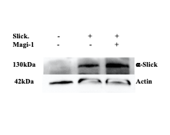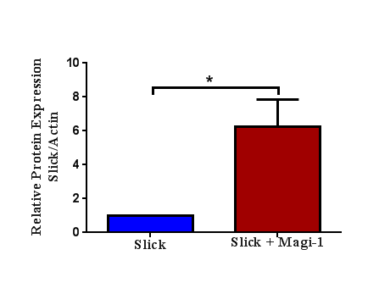

**Fig. 1** Representative immunoblot showing the increased expression of Slick due to the presence of Magi-1 (Left). Quantification of the increased Slick channel expression in CHO cells with Magi-1 (right). Three different cultures per experimental condition were analyzed and the values are expressed as Mean ± SEM (Student’s t-test, p<0.05).

1. ***Magi-1 binds to the PPxY motif at the C-terminus of the Slick Channel through its WW domain:***

To confirm the site of interaction between slick channel and Magi-1, we recognized the PPxY motif in the C-terminus and mutated the tyrosine(Y) at the 15th position with Alanine (A) whereby changing the structure of the PPxY motif.

We cultured CHO and transfected with Y15A Slick channel (control) and Y15A Slick with Magi-1 (test). We observed that the protein levels in the cells expressing only the mutated slick was not significantly different from the cells co-transfected with both the Y15A Slick and Magi-1, suggesting the site of interaction as the PPxY motif with the WW domain. These results suggest that Magi-1 protects the slick channel from degradation by the ULs by preventing their binding.

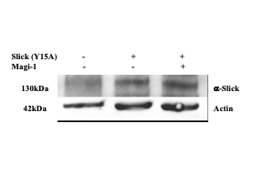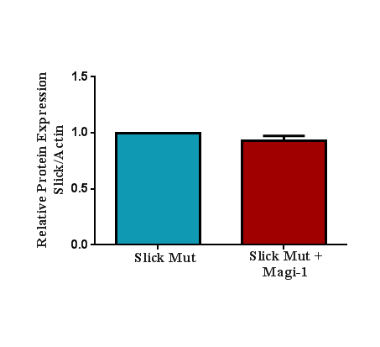

**Fig. 2** Representative immunoblot showing the expression of Mutated Slick (Y15A) and Mutated Slick co-transfected with Magi-1 (Left). Quantification of the Mutated Slick channel expression in CHO cells with Magi-1 (right). Three different cultures per experimental condition were analyzed and the values are expressed as Mean ± SEM (Student’s t-test, p<0.05).

## PART II: GluA1 subunit of AMPAR and Magi proteins

1. ***Magi-1 did not alter GluA1 protein levels in HEK-293 cells:***

To investigative the interactions of Magi-1 with GluA1, we cultured HEK-293 cells transfected with GluA1 and co-transfected with pcDNA (control) or Magi-1 (test) and observed the protein levels. We did not see any significant alteration in protein levels in GluA1 due to Magi-1 presence in these cells. These results indicate that Magi-1 does not interact with GluA1. We then wanted to observe Magi-2 interaction with GluA1.

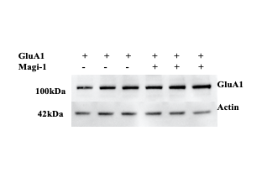 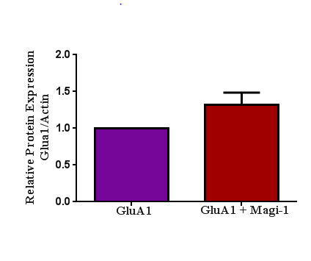

**Fig. 3** Representative immunoblot showing the expression of GluA1 and GluA1 in the presence of Magi-1(Left). Quantification of the GluA1 expression in HEK-293 cells with and without Magi-1 (right). Three different cultures per experimental condition were analyzed and the values are expressed as Mean ± SEM (Unpaired Student’s t-test, p<0.05). No significance was observed.

1. ***Co-transfection of HEK-293 cells with Magi-2 (SSCAM) did not alter GluA1 protein levels:***

Since Magi-1 was unable to alter protein expression, we moved on to the second member of the Magi family, known to be expressed post-synaptically. Again, we did not observe altered protein levels of GluA1 by Magi-2 (Fig. 3).

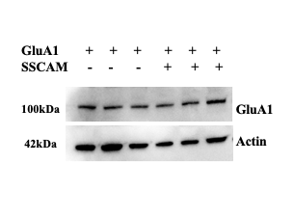 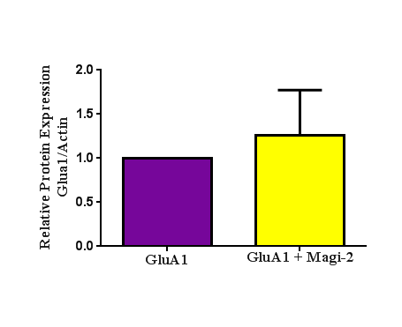

**Fig. 4** Representative immunoblot showing the expression of GluA1 alone and GluA1 with SSCAM or Magi-2 (Left). Quantification of the GluA1 subunit expression in HEK-293 cells with and without SSCAM (right). Four different cultures per experimental condition were analyzed and the values are expressed as Mean ± SEM (Unpaired Student’s t-test, p<0.05, two-tailed).

We hypothesized that the HEK-293 cells did not have sufficient endogenous ULs that could potentially interact and ubiquitinate GluA1.

1. ***Protein levels of GluA1 were significantly reducing during GluA1 co-expression with HA-Nedd4L in HEK-293 cells:***

Studies have shown that the Nedd4 family interacts with GluA1, ubiquitinating the lysine(K) at the 868th position in the C-terminus, playing a major role in turnover and trafficking of GluA1 at the synapse (Lin et al., 2011). We performed similar studies where we transfected HEK cells with GluA1 and pcDNA (control) and HA-Nedd4L (test). The presence of (freshly prepared) HA-Nedd4L in the cells remarkably reduced the total protein expression of GluA1 showing their ability of ion channel degradation by ubiquitination (Fig. 5).

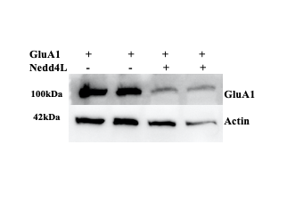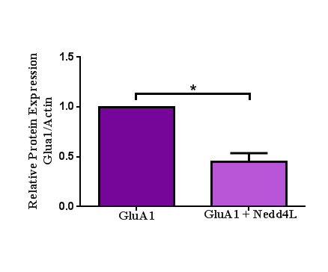

**Fig. 5** Representative immunoblot showing the decreased expression of GluA1 due to the presence of HA-Nedd4L (Left). Quantification of the decreased GluA1 subunit expression in HEK-293 cells with HA-Nedd4L (right). Seven different cultures per experimental condition were analyzed and the values are expressed as Mean ± SEM (Unpaired Student’s t-test, p<0.05, two-tailed).

1. ***GluA1 is protected from Nedd4L-dependent degradation by of Magi-2 (SSCAM):***

We then wanted to observe the protective effects of Magi-2 in the presence of Nedd4L, so we observed protein levels of GluA1 co-expressed with Nedd4L in the presence and absence of Magi-2. We observed a significant increase in total protein expression of GluA1 in the presence of Magi-2 and Nedd4L. These studies point towards GluA1 protective effects of Magi-2 against Nedd4L indicating potential sites of interaction between Magi-2 and GluA1.

Furthermore, we wanted to study whether GluA1 protective effects are Magi-2 specific so we studied interactions with other members of the Magi family.

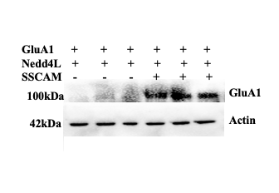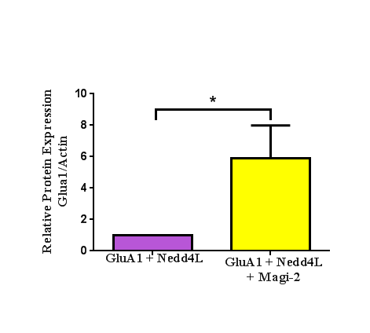

**Fig. 6** Representative immunoblot showing the increased expression of GluA1 co-transfected with Nedd4L and GluA1 with Nedd4l and SSCAM (Left). Quantification of the GluA1 subunit expression in HEK-293 cells with and without SSCAM showed a significant increase in total protein levels (Right). Five different cultures per experimental condition were analyzed and the values are expressed as Mean ± SEM (Unpaired Student’s t-test, p<0.05, two-tailed).

1. ***GluA1 protection from Nedd4L-dependent degradation is Magi-2 (SSCAM) specific:***

We observed GluA1 protein expression in the presence of Nedd4L along with Magi-1 (Fig.7). We observed no significance in the GluA1 protein levels with Magi-1 showing GluA1 protection from Nedd4L is Magi-2 specific. We did not observe significant alteration in protein levels of GluA1 in the presence of Magi-1 and Nedd4L, suggesting that Magi-1 is not involved in protecting GluA1.

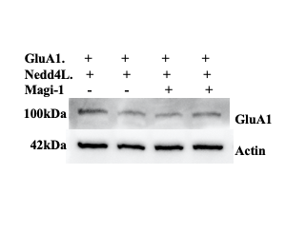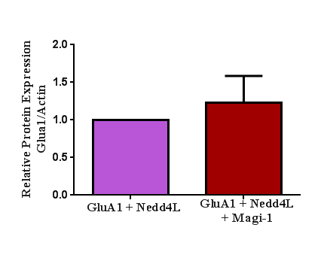

**Fig. 7** Representative immunoblot showing the expression of GluA1 co-transfected with Nedd4L and GluA1 with Nedd4l and Magi-1

(Left). Quantification of the GluA1 subunit expression in HEK-293 cells with and without Magi-1 showed no significant increase in total protein levels (Right). two different cultures per experimental condition were analyzed and the values are expressed as Mean ± SEM (Unpaired Student’s t-test, p<0.05, two-tailed).

We also studied interactions between GluA1 and PSD-95, another scaffolding protein from the Maguk family in presence of Nedd4L (Fig. 8). PSD-95 is shown to interact with AMPAR subunit with other proteins such as TARPs (Sumioka, Yan, & Tomita, 2010). Our studies focus on trying on understand direct protective effects of PSD-95 in the presence of Nedd4L. However, we did not find significant altered protein levels of GluA1 in the presence of PSD-95 and Nedd4L. Again, these results suggest that GluA1 protection is specific to Magi-2 (SSCAM).

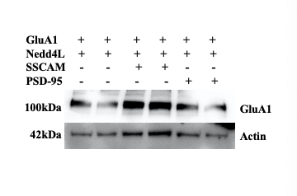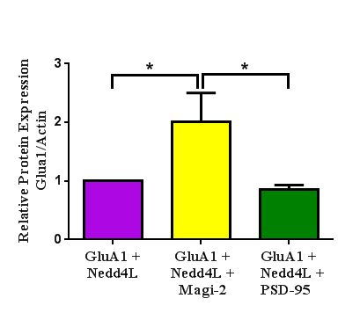

**Fig. 8** Representative immunoblot showing the increased expression of GluA1 co-transfected with Nedd4L, GluA1 with Nedd4l and SSCAM and GluA1 with Nedd4L and PSD-95 (Left). Quantification of the GluA1 subunit expression in HEK-293 cells showed a significant increase in total protein levels when cells are co-transfected with SSCAM and Nedd4L (Right). Three different cultures per experimental condition were analyzed and the values are expressed as Mean ± SEM (RM one-way ANOVA, p<0.05, Tukey’s test).

1. ***Identification of the WW binding domain in GluA1:***

The GluA1 subunit contains a putative non-canonical WW binding domain within its C-terminal. Using site-directed mutagenesis, we created a point-mutation within this domain to determine the effects of Nedd4L-dependent degradation.

As shown previously, the WT GluA1 channels exhibited a 2-fold reduction in protein expression in the presence of Nedd4L. However, mutating the site rendered GluA1 insensitive to Nedd4L-mediated degradation. In fact, we noted an increase in GluA1 expression when Nedd4L was co-expressed.

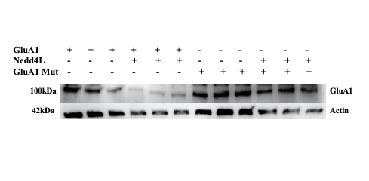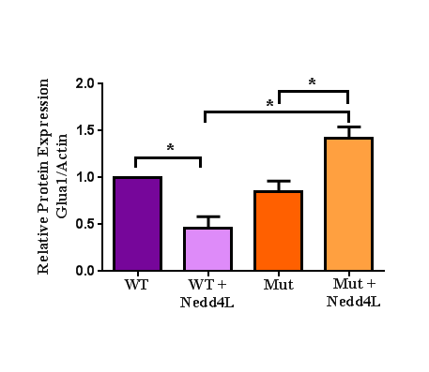

**Fig. 9** Representative immunoblot showing the decreased expression of WT GluA1 when co-transfected with Nedd4L and increased expression of Mutated GluA1 co-transfected with Nedd4L (Left). Quantification of the GluA1 subunit expression in HEK-293 cells (Right). Three different cultures per experimental condition were analyzed and the values are expressed as Mean ± SEM (RM one-way ANOVA, p<0.05, Tukey’s test).

# CHAPTER V: CONCLUSION

This work indicates the role of Magi proteins in the membrane localization and stabilization of sodium-activated potassium channel, Slick and the Glutamate ion channel subunit of AMPAR, GluA1.

1. Slick channels have shown to be regulators of inflammatory and neuropathic pain due to their expression in the DRG. Previous and current studies performed in the lab indicate that their cellular expression is due to Magi-1 binding to a particular motif, PPxY in the N-terminus of the slick channel. We believe that this site could be a potential site for therapeutic drug discovery towards the treatment of pain by selectively promoting this interaction between Magi-1 and Slick, potentiating its membrane localization and hence working towards reducing nociception.
2. GluA1, the first subunit of the AMPA receptor, forms heteromers and homomers with other subunits GluA2-4 to form a pore responsible for the influx of Na+ ions subsequently leading to Long-term potentiation. GluA1’s turnover and trafficking to the neuronal plasma membrane is an important aspect of establishing LTP, hence playing a major part in learning and memory. The studies performed in this thesis show Ubiquitin Ligase, Nedd4L-specific protection of GluA1 by Magi-2 (SSCAM). We have also identified a novel potential binding site in the GluA1 C-terminus with the WW domain in Nedd4L, helping us further understand molecular mechanisms underlying membranal tethering and protection from Ubiquitination of GluA1 elucidating novel targets to approach diseases such as epilepsy and Alzheimer’s.

# CHAPTER VI: BIBLIOGRAPHY

Ardley, H. C., Hung, C. C., & Robinson, P. A. (2005). The aggravating role of the ubiquitin-proteasome system in neurodegeneration. *FEBS Lett, 579*(3), 571-576. doi:10.1016/j.febslet.2004.12.058

Ardley, H. C., & Robinson, P. A. (2005). E3 ubiquitin ligases. *Essays Biochem, 41*, 15-30. doi:10.1042/EB0410015

Bader, C. R., Bernheim, L., & Bertrand, D. (1985). Sodium-activated potassium current in cultured avian neurones. *Nature, 317*(6037), 540-542. doi:10.1038/317540a0

Balbas, M. D., Burgess, M. R., Murali, R., Wongvipat, J., Skaggs, B. J., Mundel, P., . . . Sawyers, C. L. (2014). MAGI-2 scaffold protein is critical for kidney barrier function. *Proc Natl Acad Sci U S A, 111*(41), 14876-14881. doi:10.1073/pnas.1417297111

Bedford, M. T., Sarbassova, D., Xu, J., Leder, P., & Yaffe, M. B. (2000). A novel pro-Arg motif recognized by WW domains. *J Biol Chem, 275*(14), 10359-10369. doi:10.1074/jbc.275.14.10359

Bellinger, F. P., Fox, B. K., Chan, W. Y., Davis, L. K., Andres, M. A., Hirano, T., . . . Cooke, I. M. (2006). Ionotropic glutamate receptor activation increases intracellular calcium in prolactin-releasing cells of the adenohypophysis. *Am J Physiol Endocrinol Metab, 291*(6), E1188-1196. doi:10.1152/ajpendo.00207.2005

Bhattacharjee, A., Gan, L., & Kaczmarek, L. K. (2002). Localization of the Slack potassium channel in the rat central nervous system. *J Comp Neurol, 454*(3), 241-254. doi:10.1002/cne.10439

Bhattacharjee, A., Joiner, W. J., Wu, M., Yang, Y., Sigworth, F. J., & Kaczmarek, L. K. (2003). Slick (Slo2.1), a rapidly-gating sodium-activated potassium channel inhibited by ATP. *J Neurosci, 23*(37), 11681-11691.

Bhattacharjee, A., & Kaczmarek, L. K. (2005). For K+ channels, Na+ is the new Ca2+. *Trends Neurosci, 28*(8), 422-428. doi:10.1016/j.tins.2005.06.003

Bhattacharjee, A., von Hehn, C. A., Mei, X., & Kaczmarek, L. K. (2005). Localization of the Na+-activated K+ channel Slick in the rat central nervous system. *J Comp Neurol, 484*(1), 80-92. doi:10.1002/cne.20462

Bredt, D. S., & Nicoll, R. A. (2003). AMPA receptor trafficking at excitatory synapses. *Neuron, 40*(2), 361-379.

Chater, T. E., & Goda, Y. (2014). The role of AMPA receptors in postsynaptic mechanisms of synaptic plasticity. *Front Cell Neurosci, 8*, 401. doi:10.3389/fncel.2014.00401

Chen, H., Kronengold, J., Yan, Y., Gazula, V. R., Brown, M. R., Ma, L., . . . Kaczmarek, L. K. (2009). The N-terminal domain of Slack determines the formation and trafficking of Slick/Slack heteromeric sodium-activated potassium channels. *J Neurosci, 29*(17), 5654-5665. doi:10.1523/JNEUROSCI.5978-08.2009

Chiu, S. L., Diering, G. H., Ye, B., Takamiya, K., Chen, C. M., Jiang, Y., . . . Huganir, R. L. (2017). GRASP1 Regulates Synaptic Plasticity and Learning through Endosomal Recycling of AMPA Receptors. *Neuron, 93*(6), 1405-1419 e1408. doi:10.1016/j.neuron.2017.02.031

Danielson, E., Zhang, N., Metallo, J., Kaleka, K., Shin, S. M., Gerges, N., & Lee, S. H. (2012). S-SCAM/MAGI-2 is an essential synaptic scaffolding molecule for the GluA2-containing maintenance pool of AMPA receptors. *J Neurosci, 32*(20), 6967-6980. doi:10.1523/JNEUROSCI.0025-12.2012

Derkach, V. A., Oh, M. C., Guire, E. S., & Soderling, T. R. (2007). Regulatory mechanisms of AMPA receptors in synaptic plasticity. *Nat Rev Neurosci, 8*(2), 101-113. doi:10.1038/nrn2055

Donovan, P., & Poronnik, P. (2013). Nedd4 and Nedd4-2: ubiquitin ligases at work in the neuron. *Int J Biochem Cell Biol, 45*(3), 706-710. doi:10.1016/j.biocel.2012.12.006

Dryer, S. E., Fujii, J. T., & Martin, A. R. (1989). A Na+-activated K+ current in cultured brain stem neurones from chicks. *J Physiol, 410*, 283-296. doi:10.1113/jphysiol.1989.sp017533

Dunn, H. A., & Ferguson, S. S. (2015). PDZ Protein Regulation of G Protein-Coupled Receptor Trafficking and Signaling Pathways. *Mol Pharmacol, 88*(4), 624-639. doi:10.1124/mol.115.098509

Evely, K. M., Pryce, K. D., Bausch, A. E., Lukowski, R., Ruth, P., Haj-Dahmane, S., & Bhattacharjee, A. (2017). Slack KNa Channels Influence Dorsal Horn Synapses and Nociceptive Behavior. *Mol Pain, 13*, 1744806917714342. doi:10.1177/1744806917714342

Evely, K. M., Pryce, K. D., & Bhattacharjee, A. (2017). The Phe932Ile mutation in KCNT1 channels associated with severe epilepsy, delayed myelination and leukoencephalopathy produces a loss-of-function channel phenotype. *Neuroscience, 351*, 65-70. doi:10.1016/j.neuroscience.2017.03.035

Franklin, J. L., Yoshiura, K., Dempsey, P. J., Bogatcheva, G., Jeyakumar, L., Meise, K. S., . . . Coffey, R. J. (2005). Identification of MAGI-3 as a transforming growth factor-alpha tail binding protein. *Exp Cell Res, 303*(2), 457-470. doi:10.1016/j.yexcr.2004.10.007

Gururaj, S., Evely, K. M., Pryce, K. D., Li, J., Qu, J., & Bhattacharjee, A. (2017). Protein kinase A-induced internalization of Slack channels from the neuronal membrane occurs by adaptor protein-2/clathrin-mediated endocytosis. *J Biol Chem, 292*(47), 19304-19314. doi:10.1074/jbc.M117.804716

Gururaj, S., Palmer, E. E., Sheehan, G. D., Kandula, T., Macintosh, R., Ying, K., . . . Bhattacharjee, A. (2017). A De Novo Mutation in the Sodium-Activated Potassium Channel KCNT2 Alters Ion Selectivity and Causes Epileptic Encephalopathy. *Cell Rep, 21*(4), 926-933. doi:10.1016/j.celrep.2017.09.088

Hage, T. A., & Salkoff, L. (2012). Sodium-activated potassium channels are functionally coupled to persistent sodium currents. *J Neurosci, 32*(8), 2714-2721. doi:10.1523/JNEUROSCI.5088-11.2012

Henley, J. M., & Wilkinson, K. A. (2013). AMPA receptor trafficking and the mechanisms underlying synaptic plasticity and cognitive aging. *Dialogues Clin Neurosci, 15*(1), 11-27.

Hirao, K., Hata, Y., Yao, I., Deguchi, M., Kawabe, H., Mizoguchi, A., & Takai, Y. (2000). Three isoforms of synaptic scaffolding molecule and their characterization. Multimerization between the isoforms and their interaction with N-methyl-D-aspartate receptors and SAP90/PSD-95-associated protein. *J Biol Chem, 275*(4), 2966-2972. doi:10.1074/jbc.275.4.2966

Hollmann, M., & Heinemann, S. (1994). Cloned glutamate receptors. *Annu Rev Neurosci, 17*, 31-108. doi:10.1146/annurev.ne.17.030194.000335

Ito, H., Morishita, R., Sudo, K., Nishimura, Y. V., Inaguma, Y., Iwamoto, I., & Nagata, K. (2012). Biochemical and morphological characterization of MAGI-1 in neuronal tissue. *J Neurosci Res, 90*(9), 1776-1781. doi:10.1002/jnr.23074

Kaczmarek, L. K. (2013). Slack, Slick and Sodium-Activated Potassium Channels. *ISRN Neurosci, 2013*(2013). doi:10.1155/2013/354262

Kaczmarek, L. K., Bhattacharjee, A., Desai, R., Gan, L., Song, P., von Hehn, C. A., . . . Yang, B. (2005). Regulation of the timing of MNTB neurons by short-term and long-term modulation of potassium channels. *Hear Res, 206*(1-2), 133-145. doi:10.1016/j.heares.2004.11.023

Kameyama, M., Kakei, M., Sato, R., Shibasaki, T., Matsuda, H., & Irisawa, H. (1984). Intracellular Na+ activates a K+ channel in mammalian cardiac cells. *Nature, 309*(5966), 354-356. doi:10.1038/309354a0

Kim, G. E., & Kaczmarek, L. K. (2014). Emerging role of the KCNT1 Slack channel in intellectual disability. *Front Cell Neurosci, 8*, 209. doi:10.3389/fncel.2014.00209

Kumar, S., Harvey, K. F., Kinoshita, M., Copeland, N. G., Noda, M., & Jenkins, N. A. (1997). cDNA cloning, expression analysis, and mapping of the mouse Nedd4 gene. *Genomics, 40*(3), 435-443. doi:10.1006/geno.1996.4582

Lin, A., Hou, Q., Jarzylo, L., Amato, S., Gilbert, J., Shang, F., & Man, H. Y. (2011). Nedd4-mediated AMPA receptor ubiquitination regulates receptor turnover and trafficking. *J Neurochem, 119*(1), 27-39. doi:10.1111/j.1471-4159.2011.07221.x

Lu, W., & Roche, K. W. (2012). Posttranslational regulation of AMPA receptor trafficking and function. *Curr Opin Neurobiol, 22*(3), 470-479. doi:10.1016/j.conb.2011.09.008

Martenson, J. S., & Tomita, S. (2015). Synaptic localization of neurotransmitter receptors: comparing mechanisms for AMPA and GABAA receptors. *Curr Opin Pharmacol, 20*, 102-108. doi:10.1016/j.coph.2014.11.011

Nuwer, M. O., Picchione, K. E., & Bhattacharjee, A. (2009). cAMP-dependent kinase does not modulate the Slack sodium-activated potassium channel. *Neuropharmacology, 57*(3), 219-226. doi:10.1016/j.neuropharm.2009.06.006

Oliva, C., Escobedo, P., Astorga, C., Molina, C., & Sierralta, J. (2012). Role of the MAGUK protein family in synapse formation and function. *Dev Neurobiol, 72*(1), 57-72. doi:10.1002/dneu.20949

Park, M. (2018). AMPA Receptor Trafficking for Postsynaptic Potentiation. *Front Cell Neurosci, 12*, 361. doi:10.3389/fncel.2018.00361

Pryce, K. D., Powell, R., Agwa, D., Evely, K. M., Sheehan, G. D., Nip, A., . . . Bhattacharjee, A. (2019). Magi-1 scaffolds NaV1.8 and Slack KNa channels in dorsal root ganglion neurons regulating excitability and pain. *FASEB J, 33*(6), 7315-7330. doi:10.1096/fj.201802454RR

Sanderson, D. J., Good, M. A., Skelton, K., Sprengel, R., Seeburg, P. H., Rawlins, J. N., & Bannerman, D. M. (2009). Enhanced long-term and impaired short-term spatial memory in GluA1 AMPA receptor subunit knockout mice: evidence for a dual-process memory model. *Learn Mem, 16*(6), 379-386. doi:10.1101/lm.1339109

Schwarz, L. A., Hall, B. J., & Patrick, G. N. (2010). Activity-dependent ubiquitination of GluA1 mediates a distinct AMPA receptor endocytosis and sorting pathway. *J Neurosci, 30*(49), 16718-16729. doi:10.1523/JNEUROSCI.3686-10.2010

Shirata, N., Ihara, K. I., Yamamoto-Nonaka, K., Seki, T., Makino, S. I., Oliva Trejo, J. A., . . . Asanuma, K. (2017). Glomerulosclerosis Induced by Deficiency of Membrane-Associated Guanylate Kinase Inverted 2 in Kidney Podocytes. *J Am Soc Nephrol, 28*(9), 2654-2669. doi:10.1681/ASN.2016121356

Sumioka, A., Yan, D., & Tomita, S. (2010). TARP phosphorylation regulates synaptic AMPA receptors through lipid bilayers. *Neuron, 66*(5), 755-767. doi:10.1016/j.neuron.2010.04.035

Tamsett, T. J., Picchione, K. E., & Bhattacharjee, A. (2009). NAD+ activates KNa channels in dorsal root ganglion neurons. *J Neurosci, 29*(16), 5127-5134. doi:10.1523/JNEUROSCI.0859-09.2009

Tomasello, D. L., Hurley, E., Wrabetz, L., & Bhattacharjee, A. (2017). Slick (Kcnt2) Sodium-Activated Potassium Channels Limit Peptidergic Nociceptor Excitability and Hyperalgesia. *J Exp Neurosci, 11*, 1179069517726996. doi:10.1177/1179069517726996

Widagdo, J., Guntupalli, S., Jang, S. E., & Anggono, V. (2017). Regulation of AMPA Receptor Trafficking by Protein Ubiquitination. *Front Mol Neurosci, 10*, 347. doi:10.3389/fnmol.2017.00347

Xu, J., Paquet, M., Lau, A. G., Wood, J. D., Ross, C. A., & Hall, R. A. (2001). beta 1-adrenergic receptor association with the synaptic scaffolding protein membrane-associated guanylate kinase inverted-2 (MAGI-2). Differential regulation of receptor internalization by MAGI-2 and PSD-95. *J Biol Chem, 276*(44), 41310-41317. doi:10.1074/jbc.M107480200

Zhang, H., Wang, D., Sun, H., Hall, R. A., & Yun, C. C. (2007). MAGI-3 regulates LPA-induced activation of Erk and RhoA. *Cell Signal, 19*(2), 261-268. doi:10.1016/j.cellsig.2006.06.008

Zhu, J., Lee, K. Y., Jewett, K. A., Man, H. Y., Chung, H. J., & Tsai, N. P. (2017). Epilepsy-associated gene Nedd4-2 mediates neuronal activity and seizure susceptibility through AMPA receptors. *PLoS Genet, 13*(2), e1006634. doi:10.1371/journal.pgen.1006634